Section first:Practical on Text formatting tag
Lab 1: Make web page using Text formatting Tag.
<!DOCTYPE html>
<html lang="en">
<head>
<title>Lab 1</title>
</head>
<body>
<center><h1>HTML Assignment 1</h1></center>
<hr color="red">
<p>It is my <b>First HTML</b> Assignment. I am excited to learn HTML, and i want to make career in <b>web designing</b>.</p>
<br>
<h3>Introduction to HTML</h3>
<p>HTML (<i>Hypertext Markup Language</i>) is used to create document on the <u>World Wide Web.</u><i> It is simply a collection of certain key words called "Tags" that are helpful in writing the document to be displayed using a browser on Internet.</i> HTML was developed by <b>Tim Berners-Lee</b> in 1992.</p>
</body>
</html>

Output:
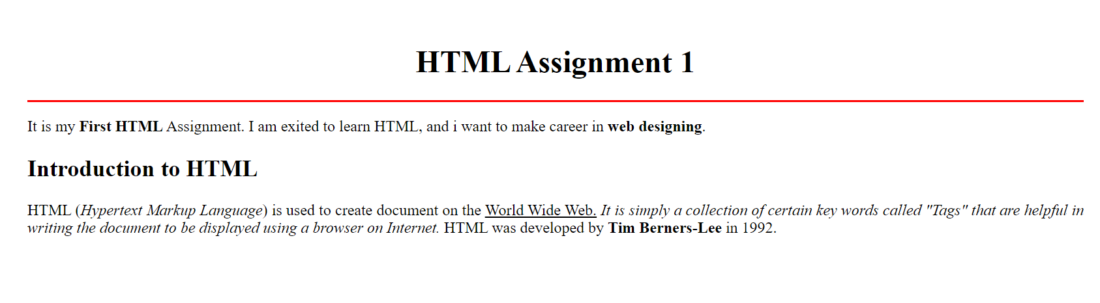

Lab 2: Make web page using Text formatting Tag.
<!DOCTYPE html>
<html lang="en">
<head>
<title>Lab 2</title>
</head>
<body>
<center><h3><u><b>
MODEL QUESTION PAPER FOR SUMMATIVE TEST-II <br>MATHEMATICS <br>CLASS-VIII
</b></u></h3></center>
<p>Minimun Marks: 20 </p>
<p><h4>General Instructions:</h4></p>
<p><ol>
<li>All questions are compulsory</li>
<li>The question paper consists of 7 question divided into 2 sections A and B</li>
<li>Section A contains 4 quesion of 2 marks.</li>
<li>Section B contains 3 question of 4 marks each.</li>
</ol></p>
<center><u><b>Section A</b></u></center>
<p>What will be the product of (a<sup>2</sup>)x(2a<sup>22</sup>)x(4a<sup>26</sup>) <br>
<ol type="a">
<li>8a<sup>46</sup></li>
<li>8a<sup>48</sup></li>
<li>6a<sup>50</sup></li>
<li>8a<sup>50</sup></li>
</ol>
</p>
<p>What is oxidised to oxygen by <br>
<ol type="a">
<li>H<sub>2</sub>O<sub>2</sub></li>
<li>KMnO<sub>4</sub></li>
<li>CIO<sub>2</sub></li>
<li>Fluorine</li>
</ol>
</p>
<p align="Center"><strike>Cutting not allowed</strike> Select only one</p>
</body>
</html>

Output:
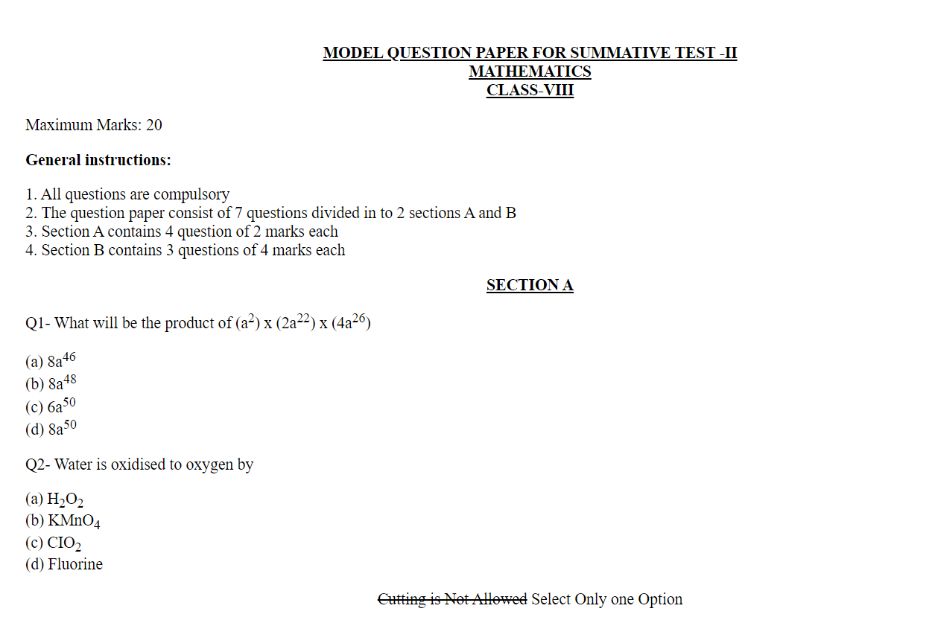
Lab 3: Make web page using Text formatting Tag.
<!DOCTYPE html>
<html lang="en">
<head>
<title>Q3</title>
</head>
<body background="download.png">
<font color ="red">
<p align="center">CURRICULUM VITAE</p>
</font>
<font color ="blue">
<h3>Devi Secondary</h3>
<p><b>Address:</b>Nikhileswor,Kathamandu</p>
<p><b>Mobile:</b>+977 9849295877</p>
<p><b>Email:</b>info@devisecondary</p>
<h3>Career Objective</h3>
<p>To perceive a career in reknowned firm with dedicated efforts and to associate myself with an organization that gives me a chance to upload my knowledge </p>
<b><u>Educational Qualification:</b></u>
<p>
Graducation BIT(Computer Science)under Tribhuvan University from Patan Multiple Campus,Lalitpur-2080.<br>
</p>
<p>

Intermediate NEB under GOV NP from LokAdarsha Academy,Kirtipur-2076<br>
</p>
<p>

SEE from Janapth School,Kuleshor-2073<br>
</p>
<b><u>Computer Skills:</u></b>
<p>PG DCA(Post Graduate in Computer Application)</p>
<p> AD CA(Advance Diplome in Computer Application)</p>
<p>DTP(Desktop Publisher)</p>
<p> Operating Systems(XP,Vista,7 and Linux)</p>
</font>
</body>
</html>

Output:
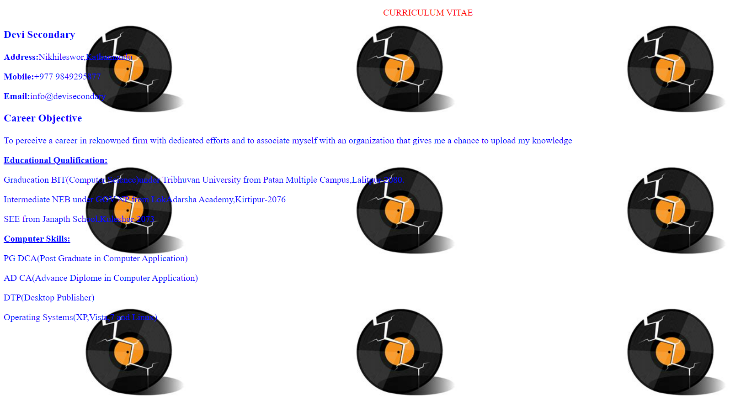

Lab 4: Make web page using Text formatting Tag.
<!DOCTYPE html>
<html lang="en">
<head>
<title>Lab 4</title>
</head>
<body background="Clouds.png">
<font size="20px">
<p><font color="red">
<center>LEEZAN CREATION<br>
<font color="Black">
Creavting stuffs
</font>
</font></font>
</center>
</p>
<p>
<hr width="90%">
<marquee><font color="white"><font size = 4><i>Welcome to My Personal Website </i></marquee>
<hr width="90%">
<img src="clouds2.png" width="400px" height="400px" align="left" />
</p>
<p align="center"><font color="yellow">
<marquee direction="up" height="400px" width="400px">
This is just a check for my new website and i am just checking my web development skill and just want to know how much capable
i am by doing the assignments that has arrived in the system.I am checking the marquee tools with the changes in the system with the
avaibility of data and i am intrested to know the things that are also actually good to know for web development
</marquee>
</font></p>
</body>
</html>

Output:

Section Second:Practical on Image tag
Lab 5: Make web page using Image Tag.
Output:
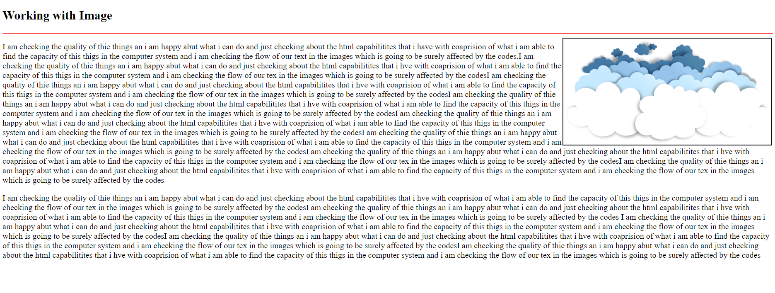
Lab 6: Make web page using Image Tag.
<!DOCTYPE html>
<html lang="en">
<head>
<title>Lab 6</title>
</head>
<body>
<h2>Images in Marquee</h2>
<p>
This is just a checking of images in the marquee and iam just checking the capacity of my web developtment skill Just ot give it a
try for my upcoming images and checking the website that is coming in line and just checking the marquee in the side with my logo
in the images and iam happy for that about.This is just a checking of images in the marquee and iam just checking the capacity of
my web developtment skill just ot give it a try for my upcoming images and checking the website that is coming in line and just checking
the marquee in the side with my logo in the images and iam happy for that abouThis is just a checking of images in the marquee and
i am just checking the capacity of my web developtment skill ust ot give it a try for my upcoming images and checking the website
that is coming in line and just checking the marquee in the side with my logo in the images and i am happy for that about
</p>
<hr>
<marquee>
<img src="clouds2.png"width=600px"/>
<img src="clouds2.png"width=600px"/>
<img src="clouds2.png"width=600px"/>
</marquee>
<hr>

</body>
</html>
Output:
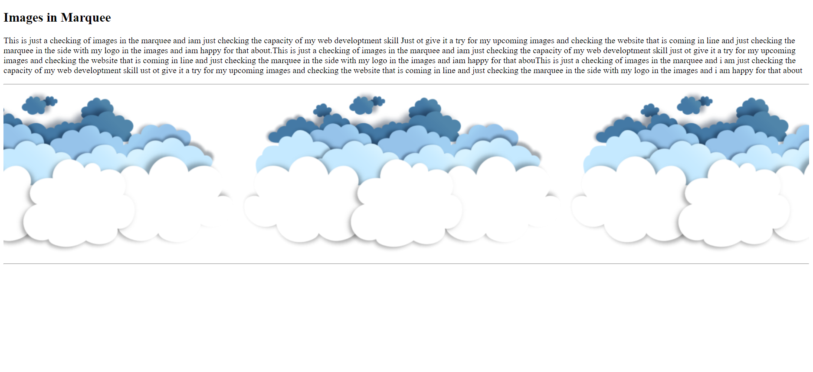

Section third:Practical on list tag
Lab 7: Make web page using list Tag.
<!DOCTYPE html>
<html lang="en">
<head>
<title>Lab 7</title>
</head>
<body>
<marquee><b>List of Courses</b></marquee>
<h3>Certificate courses</h3>
<ul type="square">
<li>CCA</li>
<li>DTP</li>
<li>TALLY</li> </ul>
<h3>NIELIT Courses</h3>
<ul type="I">
<li>CCC</li>
<li>O LEVEL</li>
<li>A LEVEL</li>
</ul>
<h3>DIPLOMA Courses</h3>
<ol type="A">
<li>DCA</li>
<li>ADCA</li>
<li>DFA</li>
<li>DDNT</li>
</ol>
<h3>Programming Courses</h3>
<ol type="1" start="11">
<li>Python</li>
<li>JAVA</li>
<li>C Programming</li>
<li>C++</li>
<li>Data Structure in C</li>
</ol>
<h3>Web Designing Course</h3>
<ol type="1">
<li>HTML</li>
<li>CSS</li>
<li>BOOTSTRAP</li>
<li>JAVASCRIPT</li>
<li>JQUERY</li>
<li>MySQL</li>
<li>PHP</li>

</ol>
</body>
</html>

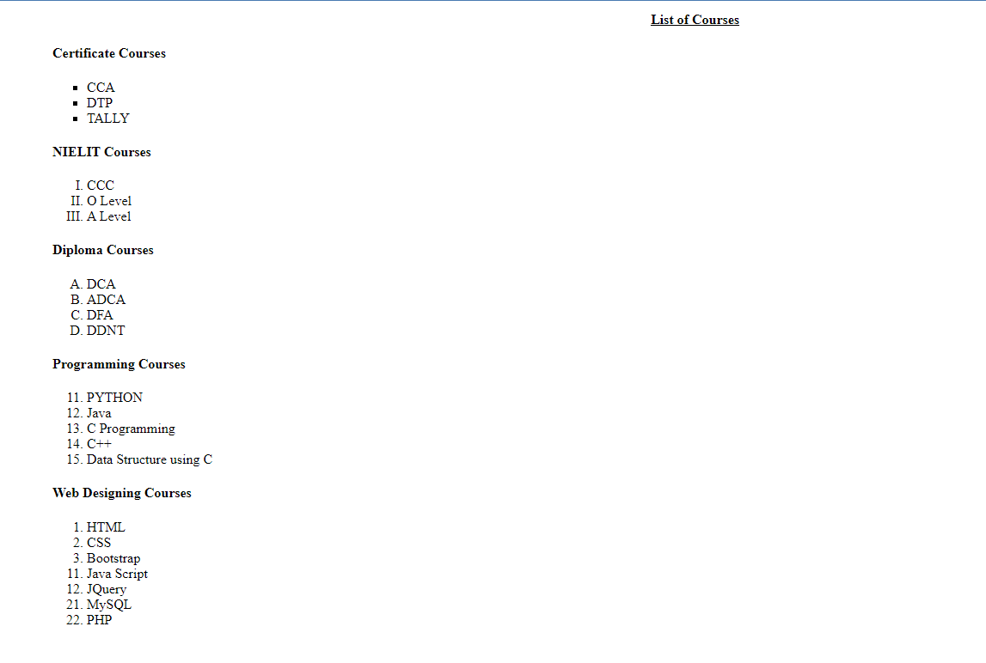
Output:
Lab 8: Make web page using nested list Tag.
<!DOCTYPE html>
<html lang="en">
<head>
<title>Lab 8</title>
</head>
<body>
<h2>Nested List</h2>
<ol type="I">
<li>Background Skills</li>
<ol type="A">
<li>Unix Commands</li>
<li>Vim text Editors</li>
</ol>
<li>HTML</li>
<ol type="A">
<li>Minimal Page</li>
<li>Headings</li>
<li>Elements</li>
<li>Lists</li>
<ol type="i">
<li>Unordered</li>
<li>Ordered</li>
<li>Definition</li>
<li>Nested</li>
</ol>
<li>Links</li>
<ol type="i">
<li>Absolute</li>
<li>Relative</li>
</ol>
<li>Images</li>
</ol>
<li>CSS</li>
<ol type="A">
<li>Anatomy</li>
<li>Basic Selectors</li>
<ol type="i">
<li>ELements</li>
<li>CLass</li>
<li>ID</li>
<li>Group</li>
</ol>
<li>DOM</li>
<li>Advance Selectors</li>
<li>Box Model</li>
</ol>
<li>Programming</li>
<ol type="A">
<li>Python</li>
<li>JavaScrpt</li>
</ol>
<li>Database</li>
<ol type="A">
<li>FlatFIile</li>
<li>Relational</li>
</ol>
</body>
</html>
Output:
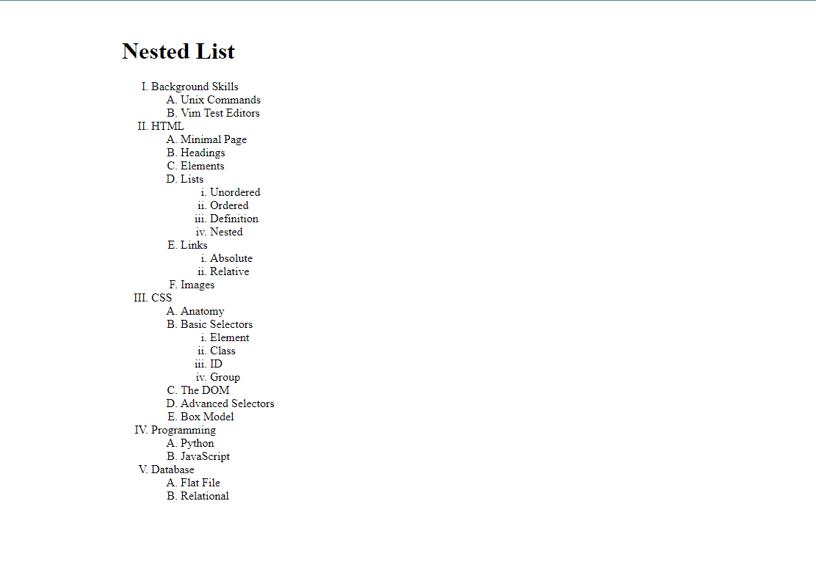
Lab 9: Make web page using definition list Tag.
<!DOCTYPE html>
<html lang="en">
<head>
<title>Lab 9</title>
</head>
<body>
<h1>Input Output devices</h1>
<dl>
<dt>Mouse</dt>
<dd>Mouse is an input device also known as pointing device</dd>
<dt>Printer</dt>
<dd>Printer is an optput device which provides hardcopy as output</dd>
<dt>Monitor</dt>
<dd>Monitor is an output device which provides softcopy as output</dd>
</dl>
</body>
</html>

Output:
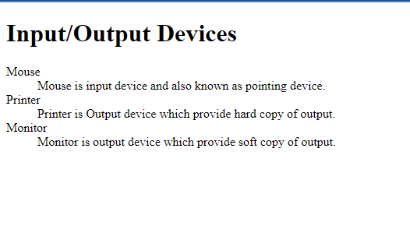
Section fourth:Practical on table tag

Lab 10: Make web page using Table Tag.
<!DOCTYPE html>
<html lang="en">
<head>
<title>Lab 10</title>
</head>
<body>
<h3 align="center">Basic Course</h3>
<table border="4px"width="90%" height="300px">
<tr bgcolor="maroon">
<th>S.NO</th>
<th>CourseName</th>
<th>Fees</th>
<th>Duration</th>
<th>Eligibility</th>
</tr>
<tr bgcolor="red">
<th>1</th>
<th>CCC-Course on Computer Concept</th>
<th>2000</th>
<th>3MOnths</th>
<th>10<sup>th</sup></th>
</tr>
<tr bgcolor="red">
<th>2</th>
<th>CCA-Course on Computer Applications</th>
<th>2000</th>
<th>3 MOnths</th>
<th>10<sup>th</sup></th>
</tr>
<tr bgcolor="red">
<th>3</th>
<th>Tally</th>
<th>3000</th>
<th>3 Months</th>
<th>10<sup>th</sup></th>
</tr>
<tr bgcolor="red">
<th>4</th>
<th>O Level</th>
<th>15000</th>
<th>1 Year</th>
<th>12<sup>th</sup></th>
</tr>
</table>

</body>
</html>

Output:
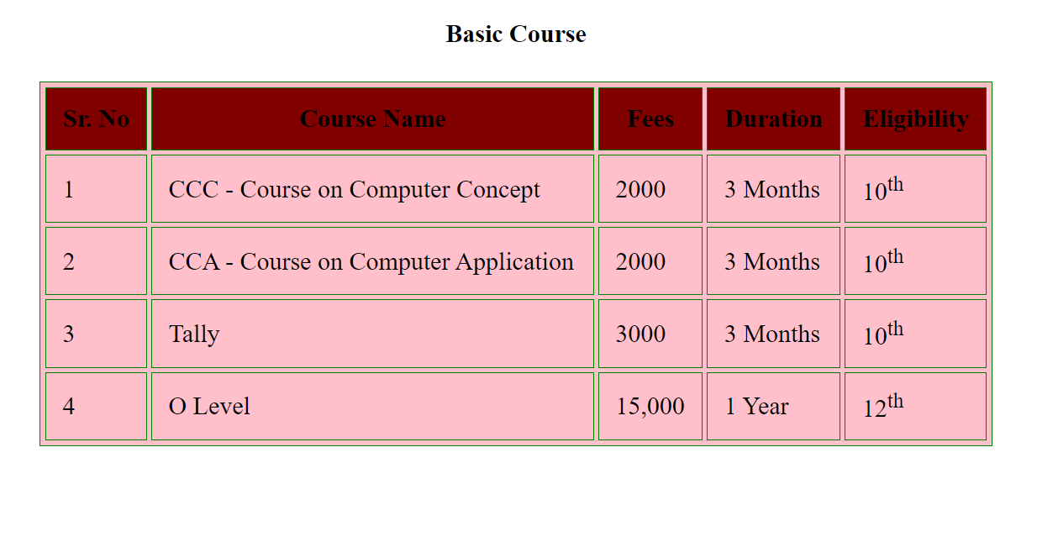

Lab 11: Make web page using Table Tag.
<!DOCTYPE html>
<html lang="en">
<head>
<title>Lab 11</title>
</head>
<body>
<table border="4px" width="100%">
<tr height="40px">
<td align="center" colspan="100%">
Time Tale</td></tr>
<tr><td rowspan="99.5%" align="center">Hours</td>
<tr align="center" height="50px">
<th>Mon</td>
<th>Tue</td>
<th>Wed</td>
<th>Thu</td>
<th>Fri</td>
</tr>
<tr height="50px">
<td>Science</td>
<td>Maths</td>
<td>Science</td>
<td>Maths</td>
<td>Arts</td>
</tr>
<tr height="50px">
<td>Science</td>
<td>Maths</td>
<td>Science</td>
<td>Maths</td>
<td>Arts</td>
</tr>
<th colspan="100%" align="center" height="50px">LUNCH</th>
<tr height="50px">
<td>Science</td>
<td>Maths</td>
<td>Science</td>
<td>Maths</td>
<td rowspan="2">Projects</td>
</tr>
<tr height="50px">
<td>Science</td>
<td>Maths</td>
<td>Science</td>
<td>Maths</td>
</tr>
</table>

</body>
</html>

Output:
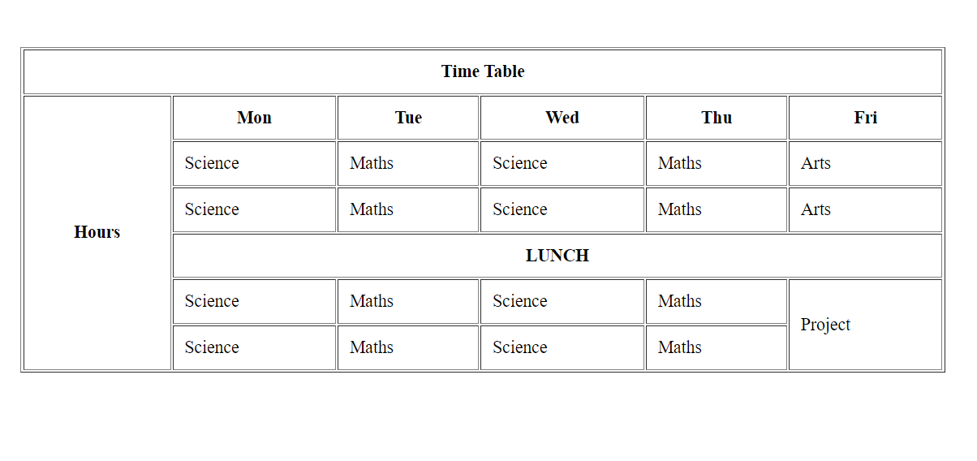
Lab 12: Make web page using Table Tag.
<!DOCTYPE html>
<html lang="en">
<head>
<title>Lab 12</title>
</head>
<body>
<h2 align="center">TIME TABLE</h2>
<table border="4px" width=100%>
<tr height="75px">
<th>Day/Period</th>
<th>I <br>9:30-10:20</th>
<th>II <br>10:20-11:10</th>
<th>III <br>12:00-12:40</th>
<th> 12:00-12:40</th>
<th>IV <br>12:40-1:30</th>
<th>V <br>1:30-2:20</th>
<th>VI <br>2:20-3:10</th>
<th>VII <br>3:10-4:00</th>
</tr>
<tr height="40px">
<td>Monday</td>
<td>Eng</td>
<td>Math</td>
<td>Che</td>
<td rowspan="5" align="center">LUNCH</td>
<td colspan="3" align="center">LAB</td>
<td>Phy</td>
</tr>
<tr height="40px">
<td>Tuesday</td>
<td colspan="3">LAb</td>
<td>Eng</td>
<td>Che</td>
<td>Math</td>
<td>SPORTS</td>
</tr>
<tr height="40px">
<td>Wednesday</td>
<td>Math</td>
<td>Phy</td>
<td>Eng</td>
<td>Che</td>
<td colspan="3">LIBRARY</td>
</tr>
<tr height="40px">
<td>Thrusday</td>
<td>Phy</td>
<td>ENg</td>
<td>Che</td>
<td colspan="3">Lab</td>
<td>math</td>
</tr>
<tr height="40px">
<td>Friday</td>
<td>Phy</td>
<td>ENg</td>
<td>Che</td>
<td colspan="3">Lab</td>
<td>math</td>
</tr>
</table>

</body>
</html>

Output:
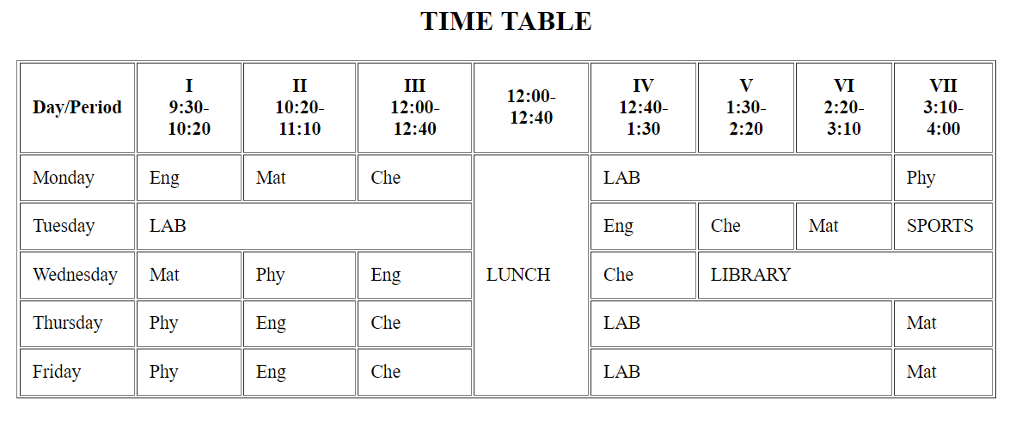
Lab 13: Make web page using Table Tag.
<!DOCTYPE html>
<html lang="en">
<head>
<title>Lab 13</title>
</head>
<body>
<h3 align="center">Web Infomax IT Solutions</h3>
<table border="1px" width="100%">
<tr>
<th rowspan="2">S.NO</th>
<th rowspan="2">Details of the Services provided</th>
<th rowspan="2">Qty</th>
<th colspan=2>Service Period</th>
<th colspan="5">Service Performance Details</th>
</tr>
<tr align="center">
<td height="60" width="50">From </td>
<td width="30">To</td>
<td>S.No</td>
<td>Service ID No.</td>
<td>Gap in Service Days</td>
<td>Overall Performance</td>
</tr>
<tr align="center">
<td height="250px" rowspan="3">1</td>
<td rowspan="3"></td>
<td></td>
<td></td>
<td></td>
<td>1</td>
<td></td>
<td></td>
<td></td>
</tr>
<tr align="center">
<td></td>
<td></td>
<td></td>
<td>2</td>
<td></td>
<td> </td>
<td></td>
</tr>
<tr align="center">
<td></td>
<td></td>
<td></td>
<td>3</td>
<td></td>
<td></td>
<td></td>
</tr>
<tr align="center"c>
<td height=200px rowspan="2">2</td>
<td rowspan="2"></td>
<td></td>
<td></td>
<td></td>
<td>1</td>
<td></td>
<td></td>
<td></td>
</tr>
<tr align="center">
<td></td>
<td></td>
<td></td>
<td>2</td>
<td></td>
<td></td>
<td></td>
</tr>
</th>
</table>
</body>
</html>

Output:
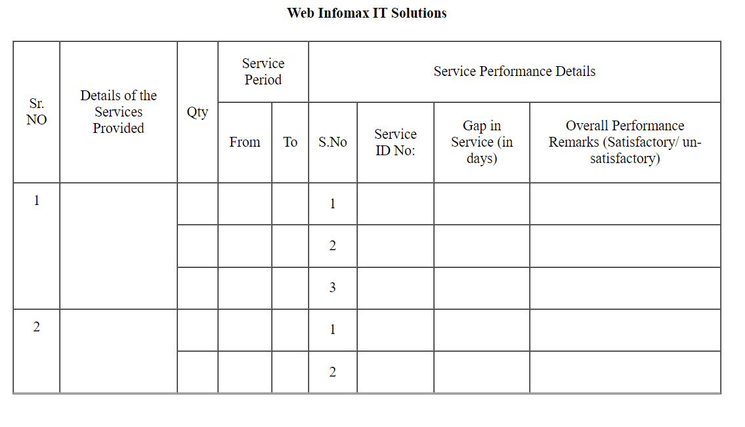

Section fifth:Practical on form tag

Lab 15:Make web page using form Tag.
<!DOCTYPE html>
<html lang="en">
<head>
<title>Lab 15</title>
</head>
<body>
<table border="1px" width="100%">
<th colspan="2" height="50px">Registration Form</th>
<tr>
<td>Student Name</td>
<td>
<form>
<input type="name">
</form>
</tr>
<tr>
<td>Fathers Name</td>
<td>
<form>
<input type="name">
</form>
</td>
</tr>
<tr>
<td>Mothers Name</td>
<td>
<form>
<input type="name">
</form>
</td>
</tr>
<tr>
<td>Date of Birth</td>
<td>
<form>
<input type="date">
</form>
</td>
</tr>
<tr>
<td>Gender</td>
<td>
<form>
Male<input type="radio">
Female<input type="radio">
</form>
</td>
</tr>
<tr>
<td>Email ID</td>
<td>
<form>
<input type="email">
</form>
</td>
</tr>
<tr>
<td>Mobile number</td>
<td>
<form>
<input type="tel">
</form>
</td>
</tr>
<tr>
<td height="100px">Address</td>
<td>
<form>
<textarea name="" id="" cols="30" rows="5">
</textarea>
</form>
</td>
</tr>
<tr>
<td>State</td>
<td>
<form>
<input type="text">
</form>
</td>
</tr>
<tr>
<td>City</td>
<td>
<form>
<input type=text>
</form>
</td>
</tr>
<tr>
<td></td>
<td>
<form>
<Button>Submit</Button>
</form>
</td>
</tr>
</table>
</body>
</html>
Output:
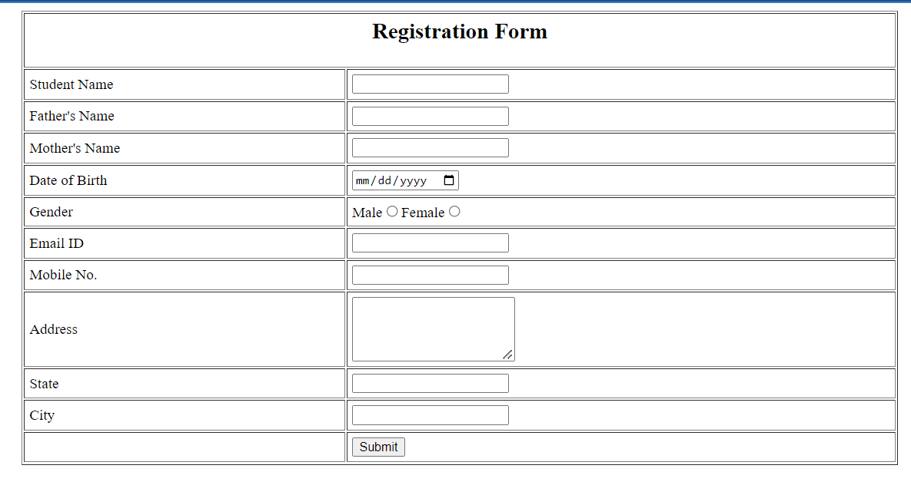
Lab 16: Make web page using form Tag.
<!DOCTYPE html>
<html lang="en">
<head>
<meta charset="UTF-8">
<meta http-equiv="X-UA-Compatible" content="IE=edge">
<meta name="viewport" content="width=device-width, initial-scale=1.0">
<title>Q15</title>
</head>
<body>
<table border="0px" width="100%">
<b>
<th colspan="2" height="50px">Registration Form</th>
<tr>
<td>Student Name</td>
<td>
<form><input type="name"></form>
</td>
</tr>
<tr>
<td>Fathers Name</td>
<td>
<form><input type="name"></form>
</td>
</tr>
<tr>
<td>Mothers Name</td>
<td>
<form><input type="name"></form>
</td>
</tr>
<tr>
<td>Date of Birth</td>
<td>
<form><input type="date"></form>
</td>
</tr>
<tr>
<td>Gender</td>
<td>
<form>
Male<input type="radio">
Female<input type="radio">
</form>
</td>
</tr>
<tr>
<td>Email ID</td>
<td>
<form><input type="email"></form>
</td>
</tr>
<tr>
<td>Mobile number</td>
<td>
<form><input type="tel"></form>
</td>
</tr>
<tr>
<td height="100px">Address</td>
<td>
<form><textarea name="" id="" cols="30" rows="5"></textarea></form>
</td>
</tr>
<tr>
<td>State</td>
<td>
<form><input type="text"></form>
</td>
</tr>
<tr>
<td>City</td>
<td>
<form><input type="text"></form>
</td>
</tr>
<tr>
<td></td>
<td>
<form><Button>Submit</Button></form>
</td>
</tr>
</b>
</table>
</body>
</html>
Output:
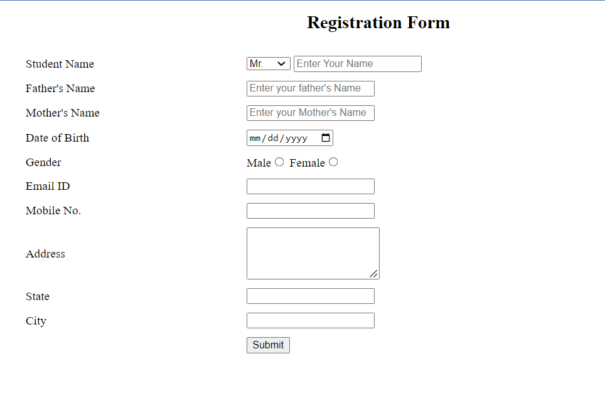
Lab 17: Make web page using form Tag.
<!DOCTYPE html>
<head>
<title>form tags</title>
</head>

<body>
<form>
<center>
<h3>Application form</h3>
</center>
<fieldset>
<table width="100%" cellpadding="5">
<legend>Personal Details</legend>
<tr>
<td> Applicant's full name:</td>
<td> <select name="fn" id="fn">
<option value="">--Select--</option>
<option value="Mr">Mr</option>
<option value="Mrs">Mrs</option><input type="text"> </td>
<td> Care of:</td>
<td><input type="radio" name="Caretaker" value="Parent">Parent<input type="radio" name="Caretaker"
value="Guardian">Guardian
</td>
</tr>
<tr>
<td> Father's Name</td>
<td> <select name="fn" id="fn">
<option value="">--Select--</option>
<option value="Mr">Mr</option>
<option value="Mrs">Mrs</option><input type="text"> </td>
<td> Mother's Name </td>
<td><select name="fn" id="fn">
<option value="">--Select--</option>
<option value="Mr">Mr</option>
<option value="Mrs">Mrs</option><input type="text">
</td>
</tr>
<tr>
<td> Gender </td>
<td> <input type="radio" name="gender" value="Male">Male <input type="radio" name="gender"
value="Female">Female
</td>
<td> Date of Birth </td>
<td> <input type="date" name="DOB" id="DOB">
</td>
</tr>
<tr>
<td>Marital Status</td>

<td> <select name="ms" id="ms">
<option value="">--Select--</option>
<option value="Married">Married</option>
<option value="Single">Single</option>
<option value="Divorced">Divorced</option>
</select>
</td>
<td>Category</td>
<td> <select name="c" id="c">
<option value="">--Select--</option>
<option value="1">1</option>
<option value="2">2</option>
<option value="3">3</option>
</select>
</td>
</tr>
<tr>
<td>Handicapped</td>
<td> <input type="radio" name="handicapped" value="Yes">Yes <input type="radio" name="handicapped"
value="No">No</td>
<td>Ex-Serviceman</td>
<td> <input type="radio" name="Ex-Serviceman" value="Yes">Yes <input type="radio"
name="Ex-Serviceman" value="No">No</td>
</tr>
</td>
</tr>
<tr>
<td>EWS</td>
<td> <input type="radio" name="EWS" value="Yes">Yes <input type="radio" name="EWS" value="No">No
</td>
<td>Religion</td>

<td> <select name="religon" id="religon">
<option value="">--Select--</option>
<option value="Hindu">Hindu</option>
<option value="Islam">Islam</option>
<option value="Christian">Christian</option>
</select>
</td>
</tr>
</table>
</fieldset>
<!--second-->
<fieldset>
<table width="100%" cellpadding="5">

<legend>Contact Details</legend>
<tr>
<td> Mobile number:</td>
<td> <input type="text"> </td>
<td> Email ID:</td>
<td> <input type="email">
</td>
</tr>
<tr>
<td>Address Line 1</td>
<td><input type="text"> </td>
<td>Address Line 2 </td>
<td><input type="text">
</td>
</tr>
<tr>
<td> City </td>
<td> <input type="text">
</td>
<td> State </td>
<td> <select name="state" id="state">
<option value="">--Select--</option>
<option value="1">1</option>
<option value="2">2</option>
<option value="3">3</option>
</select>
</td>
</tr>
<tr>
<td>Pin Code</td>

<td> <input type="text">
</td>
</tr>
</table>
</fieldset>
<fieldset>
<table cellpadding="5" width="100%">
<legend>Qualification Details</legend>
<tr>
<th>Sr.No</th>
<th>Qualification</th>
<th>Board/University</th>
<th>Passing year</th>
<th>Max Marks</th>
<th>Marks Obtain</th>
<th>Percentage</th>
</tr>
<tr>
<td>1</td>
<td><input type="text"></td>
<td><input type="number"></td>
<td><input type="number"></td>
<td><input type="number"></td>
<td><input type="number"></td>
<td><input type="number">%</td>
</tr>
<tr>
<td>2</td>
<td><input type="text"></td>
<td><input type="number"></td>
<td><input type="number"></td>
<td><input type="number"></td>
<td><input type="number"></td>
<td><input type="number">%</td>
</tr>
<tr>
<td>3</td>
<td><input type="text"></td>
<td><input type="number"></td>
<td><input type="number"></td>
<td><input type="number"></td>
<td><input type="number"></td>
<td><input type="number">%</td>
</tr>
<tr>
<td>4</td>
<td><input type="text"></td>
<td><input type="number"></td>
<td><input type="number"></td>
<td><input type="number"></td>
<td><input type="number"></td>
<td><input type="number">%</td>
</tr>
</table>
</fieldset>
<fieldset>
<table width="100%" cellpadding="5">
<legend>Language Knowledge</legend>
<tr>
<th>Language</th>
<th>Reading</th>
<th>Writing</th>
<th>Speaking</th>
</tr>
<tr>
<th>Hindi</th>
<th><input type="checkbox"></th>
<th><input type="checkbox"></th>
<th><input type="checkbox"></th>
</tr>
<tr>
<th>English</th>
<th><input type="checkbox"></th>
<th><input type="checkbox"></th>
<th><input type="checkbox"></th>
</tr>
<tr>
<th>Urdu</th>
<th><input type="checkbox"></th>
<th><input type="checkbox"></th>
<th><input type="checkbox"></th>
</tr>
</table>
</fieldset>
<fieldset>
<table width="100%" cellpadding="5">
<legend>Identification Details</legend>
<tr>
<td> Aadhar Card Number </td>
<td><input type="text"></td>
<td>PAN Card Number </td>
<td><input type="text"></td>
</tr>
<tr>
<td>Upload Photo</td>
<td><input type="file" name="photo" id="photo"></td>
<td>Upload Signature</td>
<td><input type="file" name="sign" id="sign"></td>
</tr>
</table>
</fieldset>
<br>
<center><input type="submit">
<input type="button" value="Back">
</center>

</form>
</body>

</html>
Output:

